Question 1 : What is a Calculated Field and why is it important in business dashboards?
A Calculated Field in Tableau is a new field created using a formula based on existing data fields.
Example:
Profit Ratio = Profit / Sales
Importance in Business Dashboards:
- Creates custom business metrics.
- Performs calculations without changing the original data.
- Helps analyze profitability, growth, discounts, and performance.
- Provides deeper insights for decision-making.
Example: A company can create a Profit Margin field to evaluate product profitability.

Question 2 : Why can’t parameters change visuals directly in Tableau?
Parameters are single-value inputs that store a value but do not directly affect visualizations.
They must be connected to:
- Calculated Fields
- Filters
- Reference Lines
- Sets
before they can influence a chart or dashboard.
Example:
A parameter may allow users to select:
- Sales
- Profit
- Quantity
But a calculated field is required to tell Tableau which measure to display.
Reason: Parameters only hold values; they do not automatically control charts.

Question 3 : When should EXCLUDE LOD be used?
EXCLUDE LOD (Level of Detail) is used when you want to remove one or more dimensions from the current view's level of detail while performing calculations.
Syntax:
{ EXCLUDE [Dimension] : AGG(Expression) }
Example:
Suppose a view shows Sales by Region and Category.
Using:
{ EXCLUDE [Category] : SUM([Sales]) }
calculates total sales at the Region level, ignoring Category.
Use Cases:
- Compare category sales against regional totals.
- Calculate percentages of total.
- Analyze performance without certain dimensions affecting calculations.

Question 4 : Difference between FIXED and INCLUDE LOD expressions?
Difference between FIXED and INCLUDE LOD Expressions
FIXED LOD | INCLUDE LOD
Calculates values at a specified level of detail regardless of the view. | Adds dimensions to the current view level of detail.
Ignores dimensions present in the visualization (except context filters). | Considers dimensions already present in the visualization.
Provides consistent results even when the view changes. | Results change when dimensions in the view change.
Syntax: { FIXED [Region] : SUM([Sales]) } | Syntax: { INCLUDE [Customer Name] : SUM([Sales]) }
Example
FIXED
{ FIXED [Region] : SUM([Sales]) }
Calculates total sales for each region regardless of other dimensions in the view.
INCLUDE
{ INCLUDE [Customer Name] : SUM([Sales]) }
Calculates sales including Customer Name in the level of detail, even if Customer Name is not displayed.

Task 1: Delivery Performance Classification (Calculated Field) Business Need Operations wants to track delivery efficiency. Task Classify orders as Fast or Delayed. Condition Delivery ≤ 30 min → Fast Else → Delayed
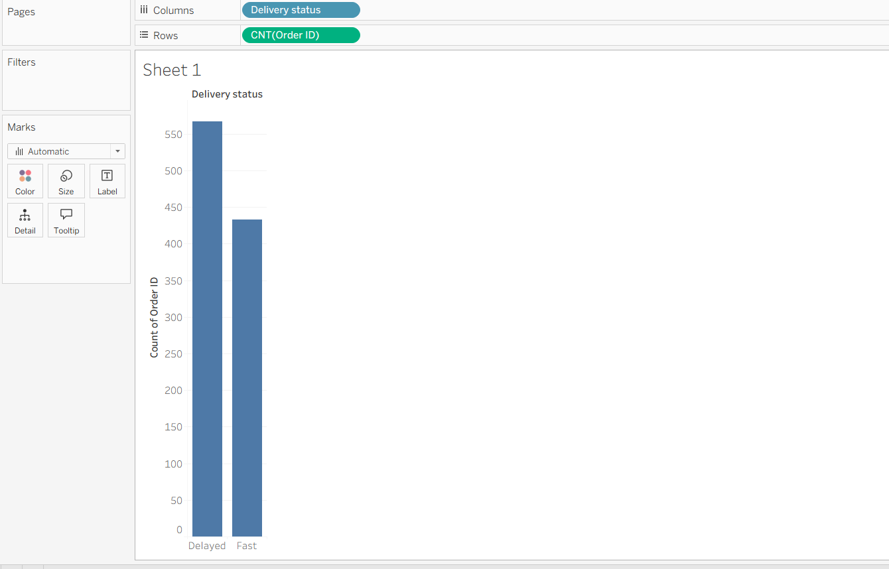
Business Insight
This classification helps Blinkit monitor delivery performance and identify areas where logistics improvements are needed. A high number of delayed orders may indicate operational bottlenecks, while a higher proportion of fast deliveries reflects efficient service.

Task 2: Loss-Making Orders Identification Business Need High sales do not always mean high profit. Task Identify orders resulting in loss.
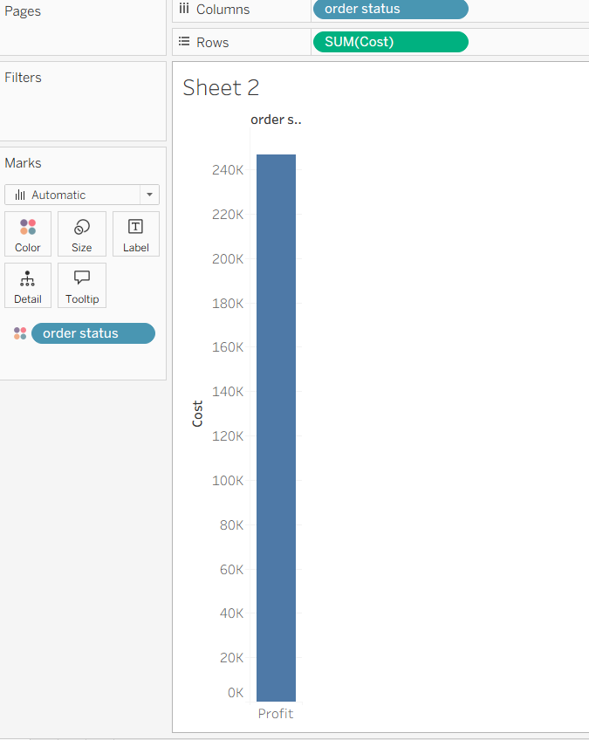
Insight
Orders classified as Loss are reducing overall profitability and should be investigated.

Task 3: Top N Products Analysis (Parameter) Business Need The product team wants to focus on top-performing products. Task Create a Top N Products dynamic analysis.
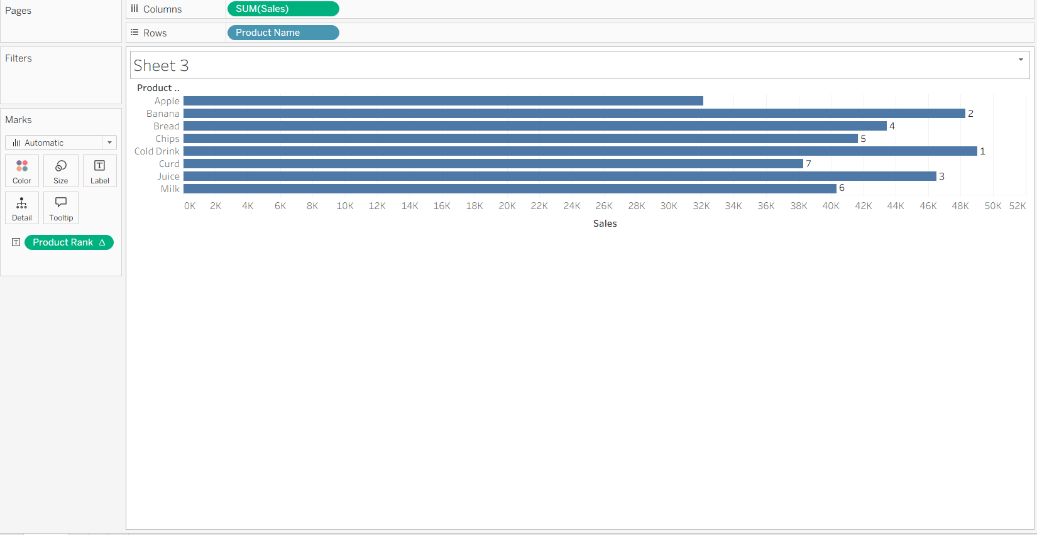

Task 4: City-Level Benchmarking (FIXED LOD) Business Need Compare city performance independent of category filters. Task Calculate average sales per city using FIXED LOD.

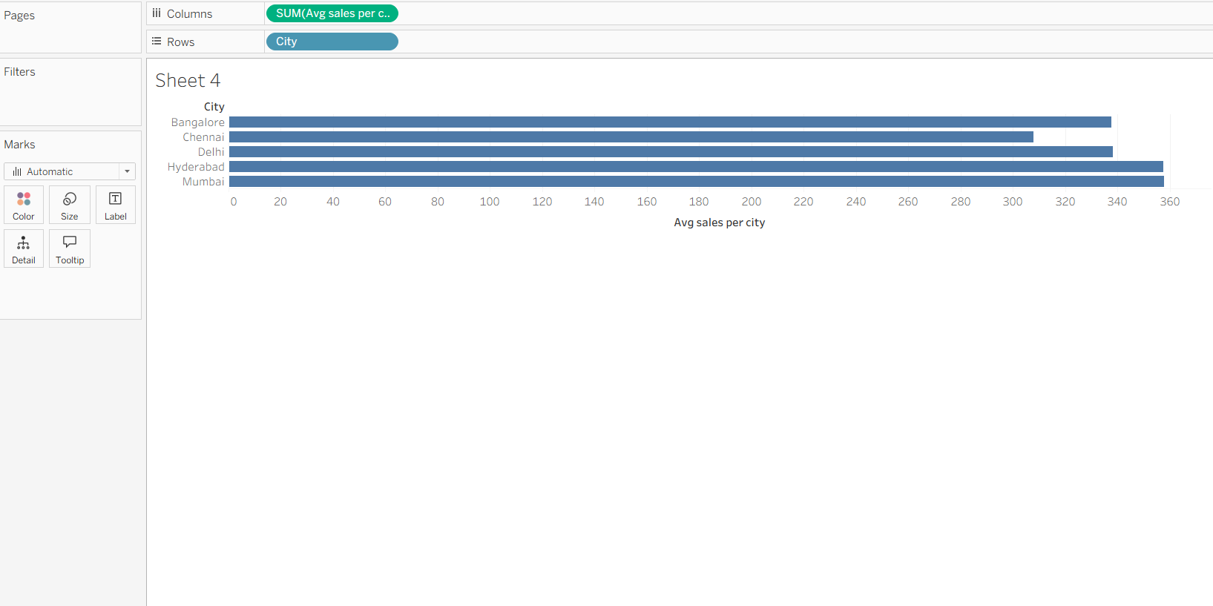
Insight
This calculation remains at the City level regardless of Category added to the view.
Business Benefit
Provides a consistent benchmark for city performance.

Task 5: Customer/Product Detail Impact (INCLUDE LOD) Business Need The sales team wants average sales considering product-level detail, even when product is not shown. Task Create a calculation that finds the average sales at the product level, but allows the result to be used at a higher level (such as Category or Region). Use INCLUDE LOD.

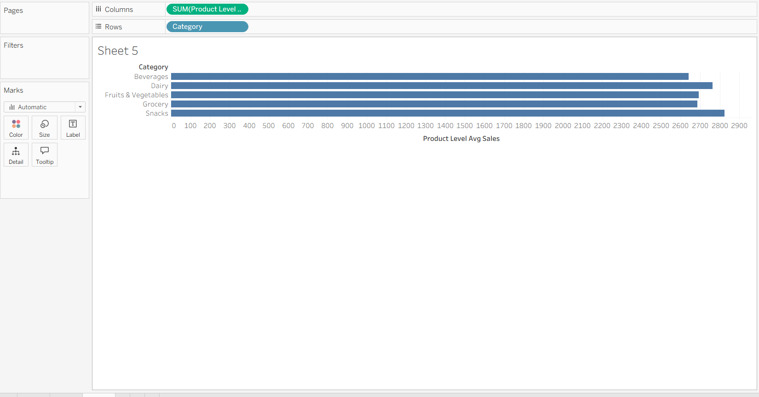

Insight
The calculation includes Product Name in the analysis even if the view only shows Category or Region.
Business Benefit
Allows management to understand product-level sales impact while viewing higher-level summaries.

